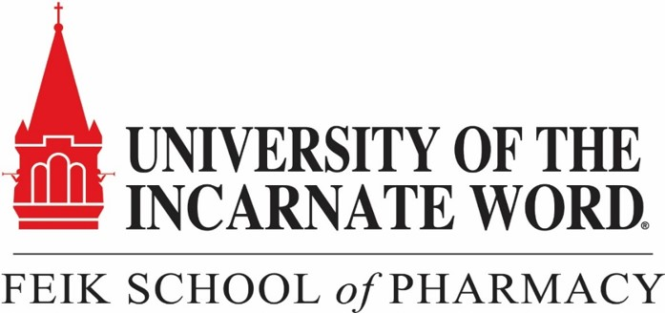
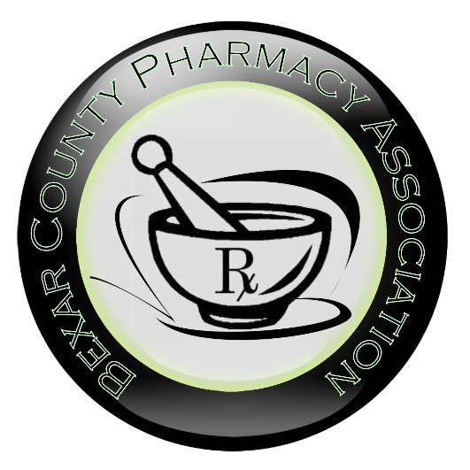

Continuing Education
present

Is GIP + GLP1 receptors agonism the key to perfect weight and glycemic control? A look into the literature for tirzepatide (GIP + GLP1 receptors agonist)
Presenter: | Lindsay Thomas, PharmD, BCACP
Clinical Specialist Pharmacist- Ambulatory Care
University Health
San Antonio, TX

Upon completion of this activity, pharmacists will be able to:
- Discuss the common characteristics and complications of a person with type 2 diabetes
- Recall tirzepatide’s mechanism of action, contraindications/precautions, dosing, benefits and risks
- Compare efficacy and safety of tirzepatide against weekly glucagon-like peptide 1 (GLP1) receptors agonist, dulaglutide and semaglutide
- Identify when tirzepatide could be used in patients with type 2 diabetes

Upon completion of this activity, pharmacy technicians will be able to:
  - Discuss the common characteristics and complications of a person with type 2 diabetes
  - Recall tirzepatide’s mechanism of action, contraindications/precautions, dosing, benefits and risks
  - Compare efficacy and safety of tirzepatide against weekly glucagon-like peptide 1 (GLP1) receptors agonist, dulaglutide and semaglutide

Date/Time: | Wednesday, January 25, 2023 from 7:00-8:00pm (Social/dinner starts at 6:30pm)
Location: | Feik School of Pharmacy
Room: | P2 Classroom (523) ***Note Room Change***
CPE Credit: | 1.0 contact hours (UANs: 0445-9999-23-003-L01-P; 0445-9999-23-003-L01-T)
Activity Type: | Application-based activity
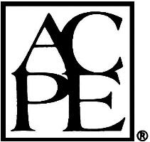
The University of the Incarnate Word Feik School of Pharmacy is accredited by the Accreditation Council for Pharmacy Education as a provider of continuing pharmacy education. This program is designed for pharmacists and pharmacy technicians to gain knowledge related GIP and GLP1 receptor agonists. There are no fees for this application-based CPE program. The pharmacist or pharmacy technician will only receive credit for programs after receiving a 70% on a post-test and an activity evaluation form is completed and submitted through FSOP’s Learning Express CE website (https://uiwfsop.learningexpressce.com/). For detailed instructions on how to use the site, see the link at https://pharmacy.uiw.edu/subsite/pharmacy/continuing-pharmacy-education/index.html. Participants will have six weeks to complete the post-test and evaluation form. The deadline to submit the post-test and evaluation form to obtain CE credit is March 10, 2023.

